Project Design Phase-II
Data Flow Diagram & User Stories

Date | 20 February 2026
Team ID | LTVIP2026TMIDS42049
Project Name | Educational Organisation Using ServiceNow
Maximum Marks | 4 Marks

🔁 Data Flow Diagram (DFD) - Level 1
Entities:
- Admin – manages setup, data entry, and evaluation
- Student – subject of data entry and academic progress
- System Database – stores and processes all relevant data
Processes:
- Student Admission – capturing student personal and admission data
- Student Progress Entry – entering marks and academic progress
- Result & Grade Generation – calculating totals, percentages, and results
Data Stores:
- D1: Salesforce Table – student personal information
- D2: Admission Table – admission-related data like status
- D3: Student Progress Table – marks, progress, results

Data Flow Summary:
- Admin inputs student details → stored in Salesforce Table
- Admission status tracked → in Admission Table
- Marks entered manually → stored in Student Progress Table
- Scripts calculate total, percentage, and result
- Data displayed in the user interface for admin verification

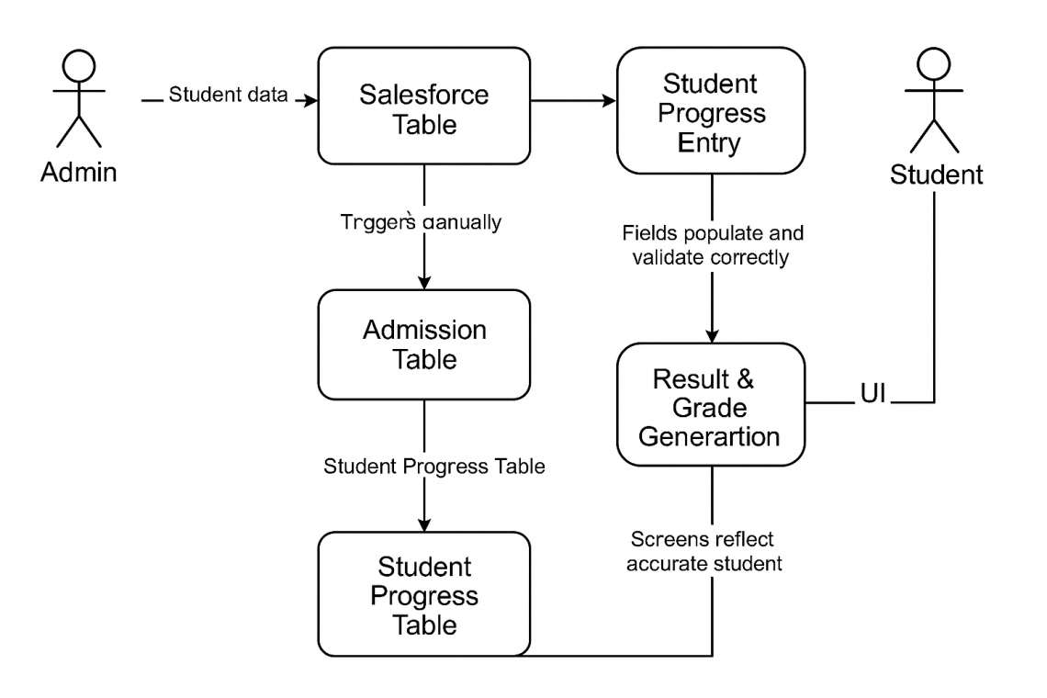

User Stories
Use the below template to list all the user stories for the product.
S.No | User Type | Functional Requirement (Epic) | User Story Number | User Story / Task | Acceptance Criteria | Priority | Release
1 | Admin | Instance Setup | USN-1 | As an admin, I can request and configure a ServiceNow developer instance | Instance is accessible and active | High | Sprint-1
2 | Admin | Table Creation | USN-2 | As an admin, I can create Salesforce and Admission tables with appropriate fields and choices | Tables are created with correct schema | High | Sprint-1
3 | Admin | UI Configuration | USN-3 | As an admin, I can design form layouts for student data input | Forms are user-friendly and functional | Medium | Sprint-1
4 | Admin | Automation Scripts | USN-4 | As an admin, I can configure client scripts to auto-fill and validate fields | Fields populate and validate correctly | High | Sprint-2
5 | Admin | Admission Process | USN-5 | As an admin, I can define admission status process flow | Admission moves through all status stages | Medium | Sprint-2
6 | Admin | Progress Evaluation | USN-6 | As a teacher/admin, I can enter marks and calculate result using scripts | Total, percentage, and result auto-generate | High | Sprint-3
7 | Admin | Output View | USN-7 | As an admin, I can view and verify the student's admission and performance data | Screens reflect accurate student progress | Medium | Sprint-3
8 | Admin | Testing | USN-8 | As a tester, I can verify all functionalities from input to result generation | All modules pass functional checks | High | Sprint-3

